**Report on Netflix Visual Data Analysis**

**Introduction**

This report provides a visual analysis of Netflix data, examining content type distribution, genre trends, release year patterns, content addition over time, and key personnel (directors and actors) and common description words. Each visualization is accompanied by a concise conclusion summarizing the key takeaway.

**Image 1: Content Type Distribution (Movies vs. TV Shows)**

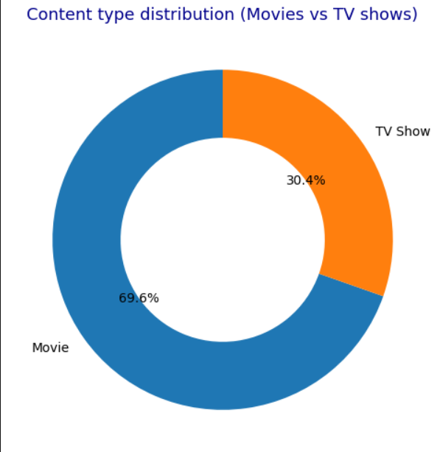

* **Description:** A donut chart showing the distribution of content type, with "Movies" comprising 69.6% and "TV Shows" 30.4%.
* **Conclusion:** Movies significantly outnumber TV shows on Netflix, indicating a strong focus on film content.

**Image 2: Top 15 Genres on Netflix**

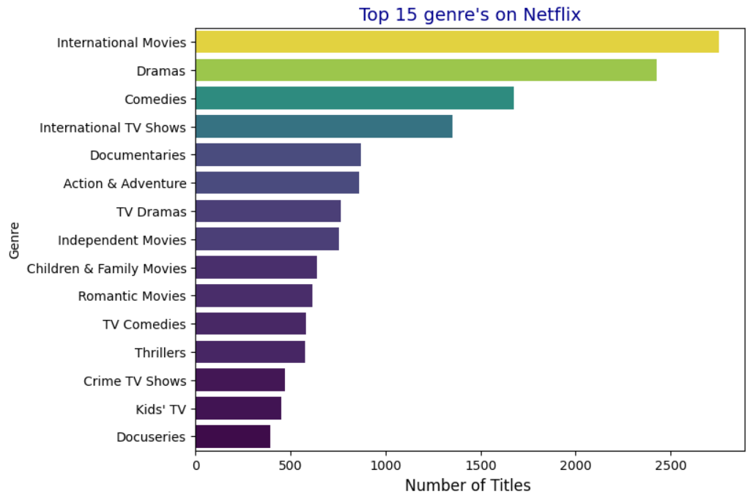

* **Description:** A horizontal bar chart displaying the top 15 genres, with "International Movies" and "Dramas" having the highest number of titles.
* **Conclusion:** Netflix's catalog is heavily populated with International Movies and Dramas, suggesting a preference for these genres.

**Image 3: Release Year Trend: Movies vs. TV Shows**

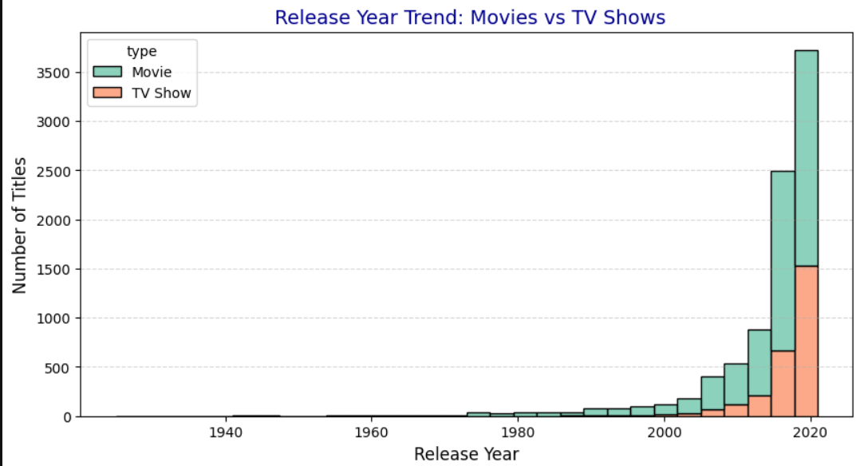

* **Description:** A stacked area chart showing the number of movie and TV show releases over the years, with a notable increase in both types of content post-2000, particularly in recent years.
* **Conclusion:** Netflix's content production has surged in the 21st century, with a substantial rise in both movies and TV shows.

**Image 4: Content Added Over Time (Heatmap)**

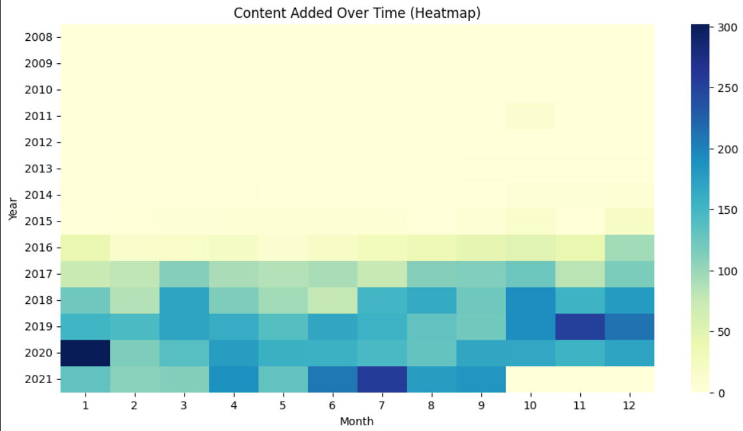

* **Description:** A heatmap visualizing content addition by year and month, showing a concentration of additions in late 2019 and throughout 2020 and 2021.
* **Conclusion:** Netflix's content library has expanded rapidly in recent years, with a peak in additions around 2020-2021.

**Image 5: Top 10 Directors on Netflix**

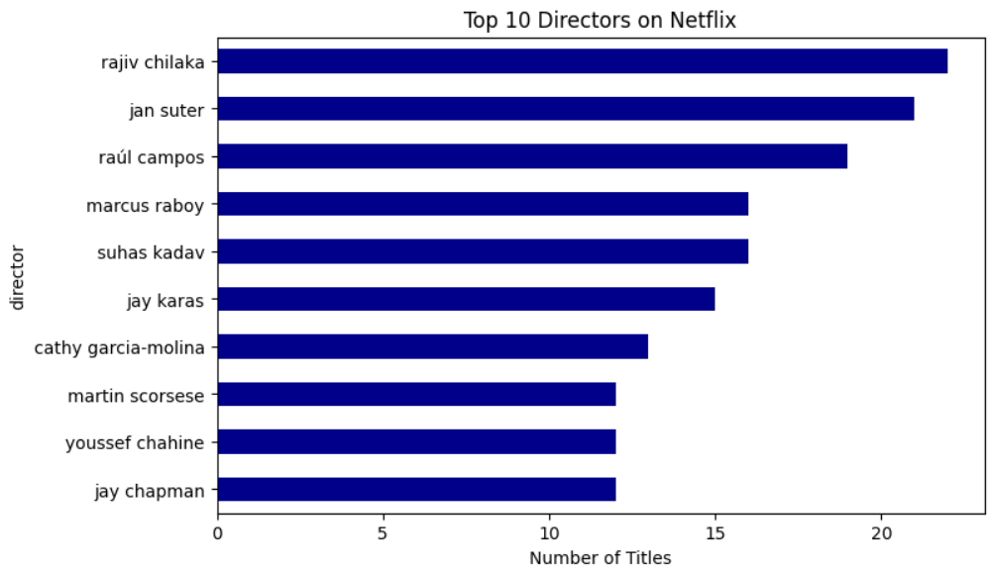

* **Description** : **A horizontal bar chart showing the top 10 directors on Netflix by the number of titles. Rajiv Chilaka leads with the highest count, followed closely by Jan Suter and Raúl Campos. The chart highlights directors with significant contributions to Netflix’s content library.**
* **Conclusion:** The chart showcases individual directors who have consistently created content for Netflix. Rajiv Chilaka emerges as the most prolific, suggesting a strong presence in children’s or animated programming. The absence of "not specified" values allows for a clearer view of actual contributors.

**Image 6: Top 10 Actors on Netflix**

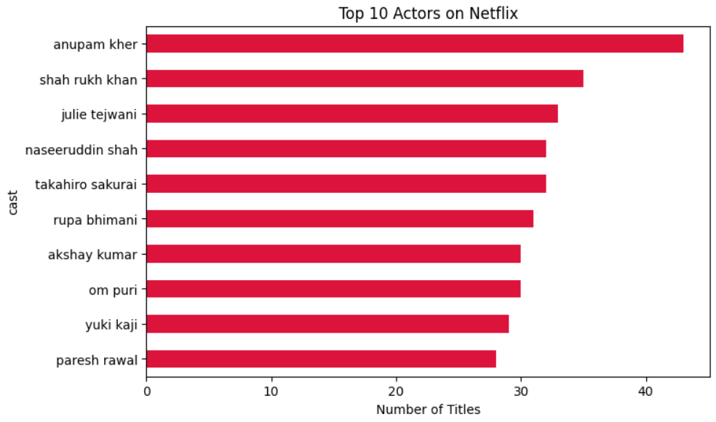

* **Description: A horizontal bar chart displaying the top 10 actors featured in Netflix titles, ranked by the number of appearances. Anupam Kher tops the list, followed by Shah Rukh Khan, Julie Tejwani, and other prominent actors from Indian and international cinema.**
* **Conclusion:** The chart highlights actors with the highest visibility on Netflix, reflecting strong representation of Bollywood and Asian content. Anupam Kher leads significantly, indicating a diverse range of appearances across various genres and formats.

**Image 7: Common Words in Netflix Descriptions**

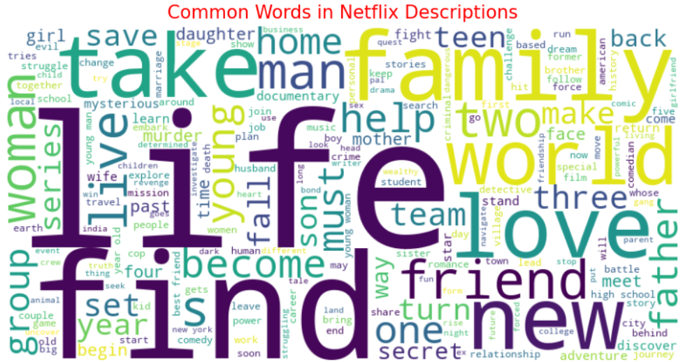

* **Description:** A word cloud displaying the most frequent words in Netflix content descriptions, with words like "life," "love," "family," and "man" prominently featured.
* **Conclusion:** Netflix's content frequently revolves around themes of relationships, personal journeys, and drama.

**Overall Report Conclusion**

This analysis reveals key trends in Netflix's content: a strong emphasis on movies, particularly international dramas; a surge in content production in recent years; data gaps in director and actor credits; and a thematic focus on personal narratives. These insights provide a valuable overview of the platform's content strategy and characteristics.